**CB[1] – Decomposition Cortland Watson**

**Type in your score here 🡪 __28__ out of 28 points**

1. (5 points) Ponder/Reflect Exercise – Reflect on what you have learned from this portion of the class. Examples of what you can do are: a brief outline of material covered, insights you gained from class or personal study, or items you feel that you need to follow up or work on. (3-5 sentences)
   1. I have been able to learn this week about block design. The most important thing that I have learned is the importance of a block design. We use it to control for Nuisance variables, and that is why we do it first in the decomposition.
2. (3 points) #A1 on pages 250-1
   1. Nuisance factor – Blocks of Farmland Unit - Plot within each block.
   2. The plots within each block of Farmland are homogenous (a shared property).
   3. Each plot within each block was randomly assigned a treatment.
3. (3 points) #A2 on pages 250-1
   1. Nuisance factor – Sets of Twins.
   2. Unit – A twin. Each person is a within a set of twins (a shared property).
   3. One twin lives in a rural area and one twin lives in an urban area. (Didn’t specify if each person was randomly assigned to live in a rural area and the other in an urban area.
4. (3 points) #A3 on pages 250-1
   1. Nuisance factor – The occasions the experimenter put cotton balls over a hive of bees.
   2. Unit – half a board of cotton balls (one half was fresh, the other half had stingers.
   3. The experimenter subdivided a block of material into two smaller chunks where one chuck had fresh cotton balls and the other half had stingers.
5. Use the file marketing.txt from the homework page. The first column is sales of a product of interest (in dollars), the second column is the shelf height factor (shelf height for the product being sold), and the third column is day of week (the blocking factor). On each day, the researcher in this study randomly assigned a product of interest to a location on a five-level store shelf and then recorded the total sales for each shelf at the end of the day. Our primary interest is to see if the shelf heights have different mean sales.
   1. (5 points) Write out a well-labeled factor diagram for these data. Also, write down the statistical model, carefully defining on the parameters in the model.
 $${ y}_{ij}=μ+β_{j}+α_{i}+ε_{ij} i=1,…,5; j=1,…,5;$$

 $$β_{j}=effect of the j^{th} day of the week$$

 $$α_{i}=effect of the i^{th} shelf level$$

   1. Included the decomposition on the uploaded excel document!
   2. (2 points) Why would the researchers choose to treat day of the week as a block?
      1. Blocking accounts for nuisance variables and in this case they could be anything from people only shopping on Monday to the store being busier on Thursday.
6. (4 points) #D9 (this is a CB[1]) on pages 278-9
   1. 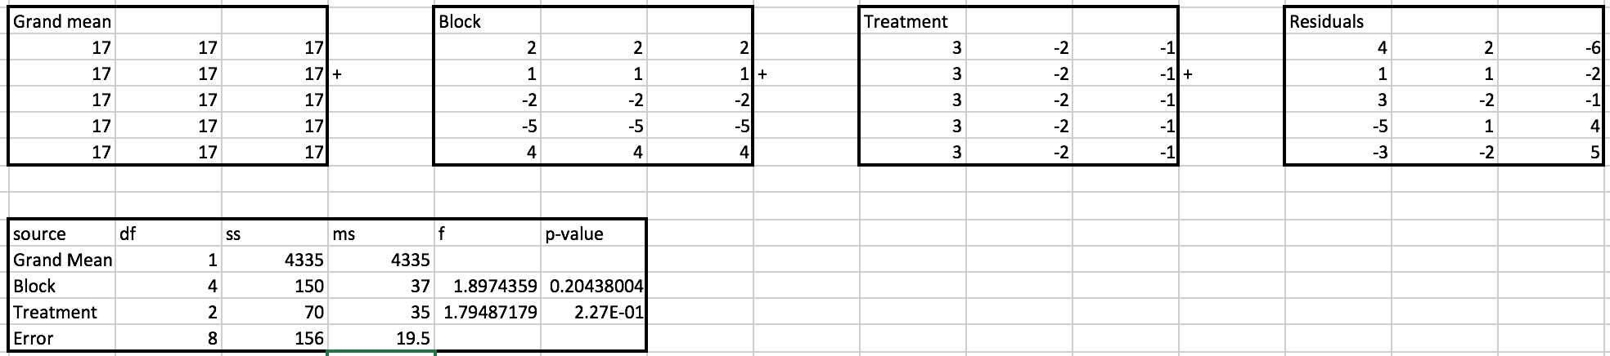
   2. (3 points) Create an ANOVA table using the effects from problem